**DAILY ONLINE ACTIVITIES SUMMARY**

|  |  |  |  |  |  |  |  |
| --- | --- | --- | --- | --- | --- | --- | --- |
| **Date:** | **12/06/2020** | | | | **Name:** | **Amrutha G** | |
| **Sem & Sec** | **4th SEM 'A' Section** | | | | **USN:** | **4AL18CS006** | |
| **Online Test Summary** | | | | | | | |
| **Subject** | | **Aadalitha kannada** | | | | | |
| **Max. Marks** | | **25** | | **Score** | | **19** | |
| **Certification Course Summary** | | | | | | | |
| **Course** | **Introduction to ethical hacking** | | | | | | |
| **Certificate Provider** | | | **greatlearning academy** | **Duration** | | | **5 hours** |
| **Coding Challenges** | | | | | | | |
| **Problem statement 1: Given two positive integer start and end. The task is to write a Python program to print all Prime numbers in an Interval.** | | | | | | | |
| **Status: completed** | | | | | | | |
| **Uploaded the report in Github** | | | | **yes** | | | |
| **If yes Repository name** | | | | **https://github.com/AMRUTHAGANESH/lockdown-java-codings-** | | | |
| **Uploaded the report in slack** | | | | **yes** | | | |

ONLINE TEST DETAILS: Aadalitha kannada test was scheduled from 11:30 am to 11:55am .The portion for the IA was all 10 chapters there were 25 questions and the time assigned was 25 minutes the questions were mcq type.

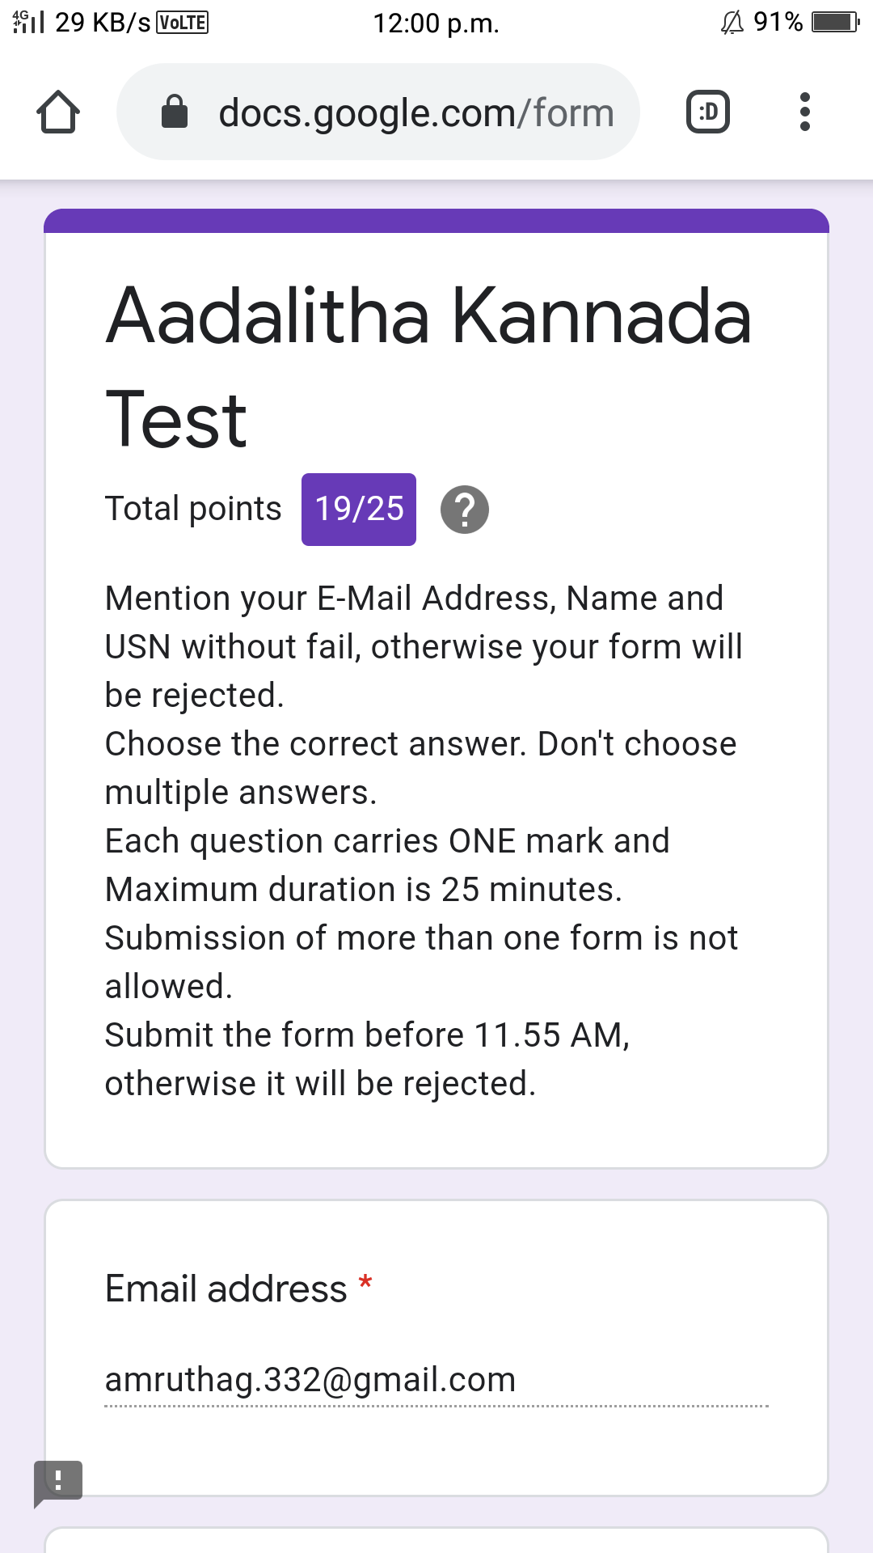

CERTIFICATION COURSE DETAILS:

Today I attended E-quiz on operating system organized by department of computer science and engineering moodalkere institution of technology in this I scored 100%

Snap shot:

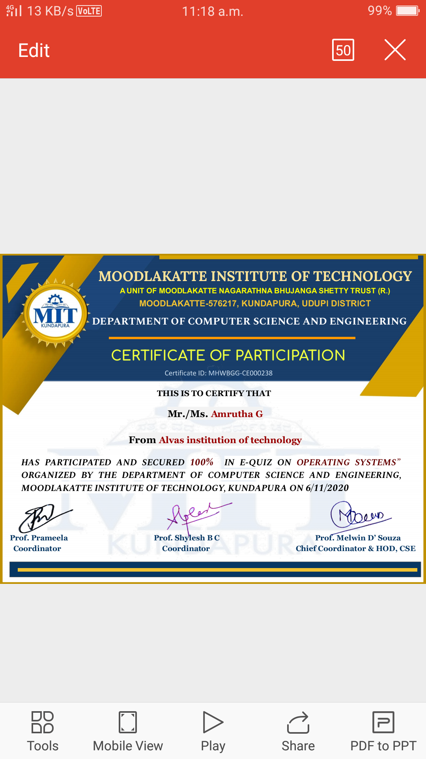

Name of the course : introduction to ethical hacking

In today's session I went through ethical hacking in network architecture and demonstration

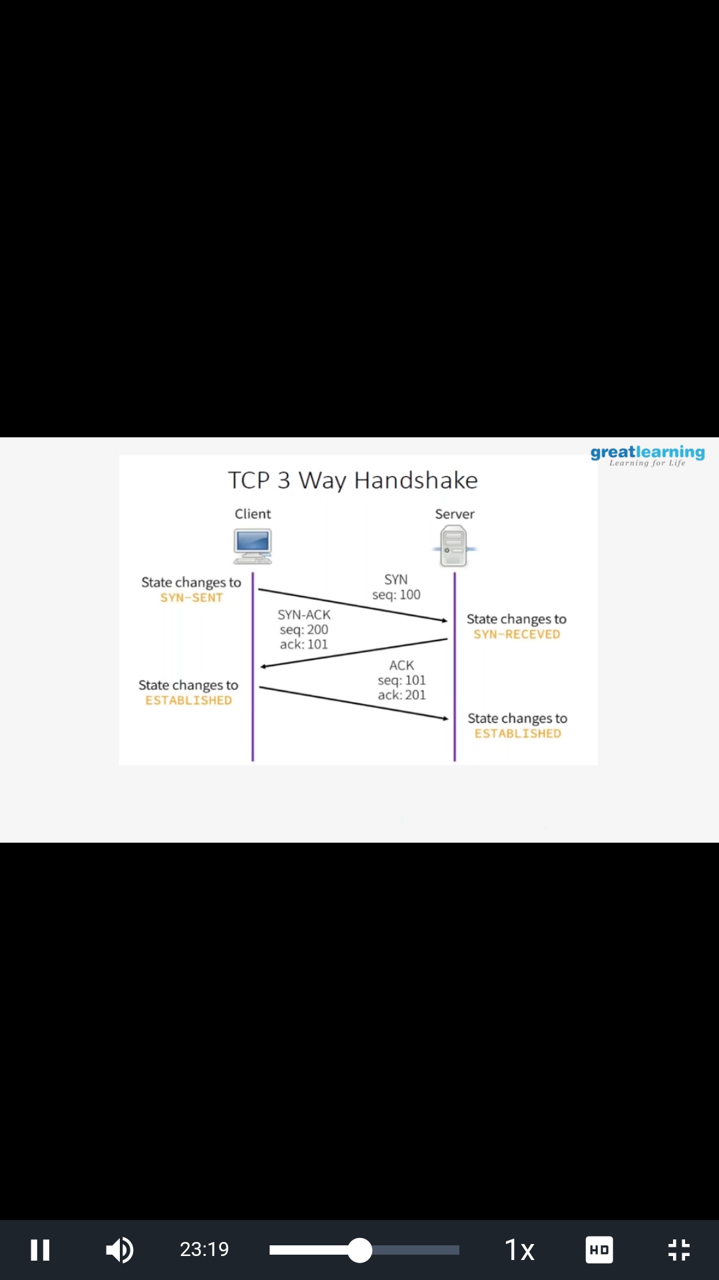

**CODING CHALLENGES DETAILS**:

**Problem statement 1: Given two positive integer start and end. The task is to write a Python program to print all Prime numbers in an Interval.**

